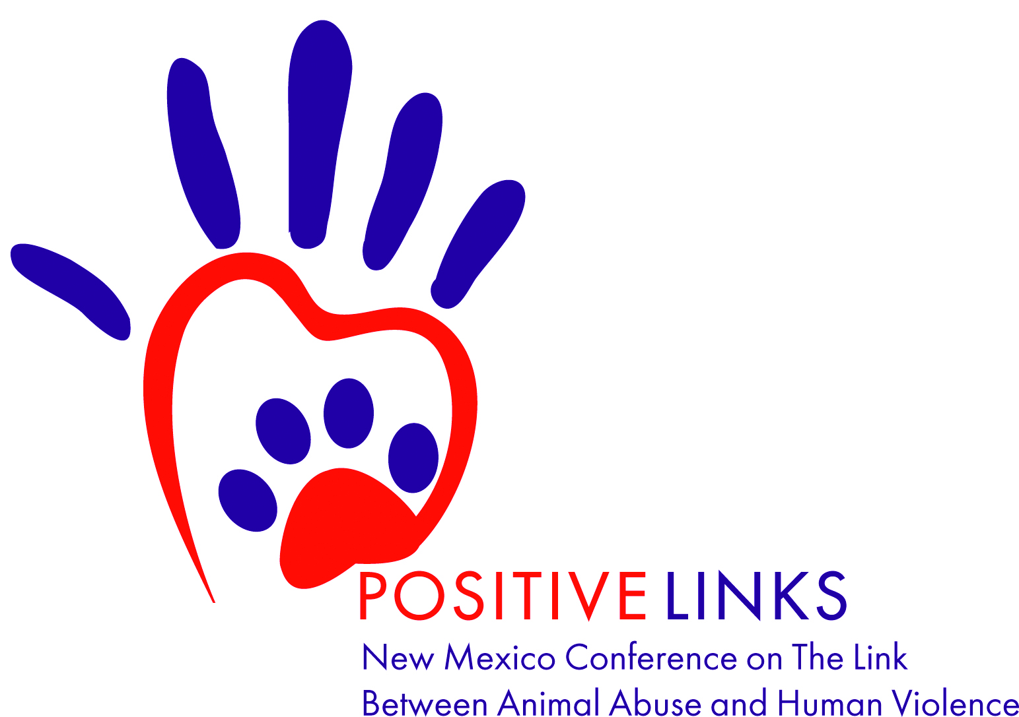 ***Exhibitor Opportunities***

### A booth at the **2019 New Mexico Conference on the Link Between Animal Abuse and Human Violence** is your opportunity to:

* Receive access to a wide range of expected professional disciplines from all over the region including: **Law Enforcement, Social Workers, Advocacy Programs, Government Agencies, Court Administrators, Educators, Activists, Tribal groups** and more!
* Raise your profile with professionals from all over New Mexico and the United States.
* Connect with collaborators and reinforce your business potential.
* Increase the visibility of your products and services to help promote a shared cause.
* Establish lasting relationships with leaders making a difference in the lives of victims of domestic violence and their companion animals.
* Network with others that share a common interest of ending cruelty to animals.

*EXHIBITOR INFORMATION*

### **LOCATION**

### Hispanic Cultural Center

### 1701 4th Street SW

### Albuquerque, NM 87102

### **EXHIBIT DATE AND TIME**

### Monday, September 9th, 7:30 a.m. to 5:00 p.m.

### **\*Details concerning set up and dismantle times will be sent out upon agenda confirmation.**

### **BOOTH FEES\***

### Sponsorship Levels at $500 and up: **FREE**

### Booth fee for Individual or Corporate Sponsors: **$50**

### Booth fee for non-sponsors: **$100**

### **\*Booth Fees include one 8’ table with two chairs. See Sponsorship form for more info.**

### **ADDITIONAL BENEFITS**

### Organization listed on conference website

### Organization listed in conference program

### Opportunity to purchase ad space in conference program

### Opportunity to purchase meals and gain additional networking time with attendees

***\*An Exhibitor Registration Form must be completed, reservations are on a first come, first serve basis.***

~ Exhibitor Registration Form ~ 

*Please complete both pages of the Exhibitor Registration Form and mail to the address provided below.*

**ORGANIZATION INFORMATION** Please list as you would like to appear in conference materials.

|  |  |
| --- | --- |
| **Organization Name** |  |
| **Address** |  |
| **City, State, Zip** |  |
| **Website** |  |

**OFFICIAL CONTACT PERSON** This person is considered the official contact of the participating organization to receive all information regarding confirmation of events and activities.

|  |  |
| --- | --- |
| **Name** |  |
| **Title** |  |
| **Phone** |  |
| **Email** |  |

**ORGANIZATION DESCRIPTION** Please provide a two or three sentence description of your organization (NOT booth) for use in marketing materials.

**BOOTH WORKERS** Please provide names of the representatives who will be at your booth. This information will be used for name badges. Badges will be placed at exhibit booth prior to your arrival. Booth workers are not eligible to attend the conference programming unless they register as a conference attendee. Meals are not included in the booth fee, but you may dine with attendees for an additional fee.

|  |  |  |  |
| --- | --- | --- | --- |
| **Name** |  | **Title** |  |
| **Name** |  | **Title** |  |

**Raffle** If you would like to donate any items to be used as raffle prizes, please describe the item(s) and quantity donating.

**EXHIBIT BOOTH**

* Sponsorship ($500 and up) -**Free**
* Individual or Corporate Sponsors- **$50**
* Flat Booth fee- **$100**

## **DINE WITH ATTENDEES**

* Breakfast, Morning Snack, Lunch & Afternoon Snack ($25.00) Quantity: ___
* I will not be dining with attendees.

## **PAYMENT INFORMATION**

* Booth Fee (if applicable) $ ____
* Meals with Attendees $ ____

**TOTAL AMOUNT DUE** $ ____

## **PAYMENT METHOD**

* Check enclosed
* Credit Card
* I have read and agree to the parameters outlined in the Exhibitor Terms and Conditions.

(Contact Person’s Signature) (Date)

*\*Please note that all products, either sold or given away, at the conference must be vegan. This includes items sold or given away at exhibitor tables, donated raffle items, or any other items that may be included as participant gifts.*



Checks can be made payable to Positive Links, Inc. Mail checks and completed Exhibitor Registration forms to:

Positive Links, Inc.

Attn: NM Conf on The Link 1445 Adams St NE

Albuquerque NM 87110 Positive Links is a 501(c)(3) charity and donations are deductible from income tax as provided by law. (Tax ID 81-1271759)

Exhibitor Terms and Conditions

**EXHIBIT LOCATION, DATES & TIMES**

The 2019 Positive Links: New Mexico Conference on The Link Between Animal Abuse and Human is taking place at the Hispanic Cultural Center, 1701 4th Street SW, Albuquerque, New Mexico 87102. Exhibit hours are Monday, September 9, 7:30 am – 5:00 pm

**OFFICIAL CONTACT PERSON**

The person named on the registration is considered the official contact of the participating organization to receive all information regarding confirmation of events and activities. This person is responsible for assuring information is properly distributed to all participating representatives. A participating representative is the person in actual attendance at the conference. Participating representatives may be listed on the application upon submission or may be submitted at a later date.

**ATTENDANCE AT CONFERENCE**

Conference attendance is not included in the exhibitor fee. Each booth worker will be issued a name badge. Meals are not included in booth fee.

**EXHIBITOR FEE**

The exhibitor fee includes an 8' table and two chairs.

**BOOTH ASSIGNMENTS**

Booth assignments will be made according to the order in which registrations were received.

**EVENT ACCOMMODATIONS**

Conference exhibitors must arrange for their own lodging.

**CANCELLATIONS**

Cancellation of exhibit space must be in writing. Cancellations received before August 31, 2019 will be refunded with a 20% service charge on the net cost of the original space. A refund for cancellation cannot be made after September 1, 2019. In the event of the conference being canceled due to causes beyond the control of the sponsoring organization, Positive Links shall not be held liable for failure to hold the conference, and Positive Links shall determine the amount of exhibit fee to be refunded.

**SHIPPING/STORAGE**

### All exhibitors are asked to make individual arrangements for shipping/handling.

### 

### **SUBSTITUTIONS AND NAME CHANGES**

Substitutions (for booth workers or contact person) are accepted at any time prior to September 1, 2019. Email [thelink@e-solved.com](mailto:thelink@e-solved.com) with substitutions.

**INDEMNITY**

It may be necessary for reasons beyond the control of the conference organizers to alter the venue, content or the timing of the program. We will endeavor to keep you informed of such changes, but any reasonable change to the conference format will not constitute a reason to refund the exhibitor fee.

**SECURITY**

Positive Links is committed to ensuring that the submission of sensitive information, such as credit card details, is safe and secure. We employ reputable and reliable service providers to ensure such information is protected. All information we hold is kept secure with access limited to personnel charged with the processing of such data.

**SAFETY**

While every effort has been made to ensure the safety of all attendees, the organizers cannot be held responsible and/or liable for any personal accident, loss or damage to private property of those attending the conference.

**RESTRICTIONS**

All decorative material must be flame proofed. Every effort will be made to maintain a business-like atmosphere. Extremely loud noises, such as bells, sirens, buzzers, etc., are not permitted. Use of audio-visual equipment must be played at a moderate volume.

**MEDIA WAIVER**

By entering the event premises and/or my participation in this event I am consenting to the use of my photograph, likeness or video or audio recording in whole or in part without restriction or limitation for any educational, promotional, or any Positive Links purpose for distribution in Positive Links online and printed publications or any publication in other media. I release Positive Links, their officers and employees, and each and all persons involved from any liability connected with the taking, recording, digitizing or publication of interviews, photographs, computer images, video and/or sound recordings.

By entering the event premises, I waive all rights I may have to any claims for payment or royalties in connection with any exhibition, streaming, web casting, televising or other publication of these materials regardless of the purpose or sponsoring of such exhibiting, broadcasting, web casting or other publication irrespective of whether a fee for admission or sponsorship is charged. I also waive any right to inspect or approve any photo, video, or audio recording taken by the Positive Links or the person or entity designated to do so by the Positive Links. I have been fully informed of my consent, waiver of liability and release before entering the event.

**DAMAGE**

Exhibitors will not fasten any fixtures to the floors, walls, columns or ceilings of the exhibit area. Exhibitors will be liable for any damages caused by such fastening and for any damage to equipment furnished by Positive Links or service suppliers designated by them.

**PERMITS/LICENSES**

Each exhibitor is responsible for obtaining all necessary licenses and permits to use music, photographs or other copyrighted material in exhibitors’ booths or displays. No exhibitor will be permitted to play, broadcast or have performed any music or use any other copyrighted material, such as photographs or other artistic works, without first presenting to Positive Links proof satisfactory that the exhibitor has, or does not need, a license to use such music or copyrighted material. Positive Links reserves the right to remove from the exhibit area all or any part of any booth or display which incorporates music, photographs or other copyrighted material for which the exhibitor fails to produce proof that the exhibitor holds all required licenses. The exhibitor shall remain liable for and shall indemnify hand hold Positive Links, their agents and employees, harmless from all loss, cost claims, causes of actions, suits, damages, liability, expenses and costs, including reasonable attorney’s fees, arising from or out of any violations or infringements (or claimed violation or infringement) by exhibitor, exhibitor’s agent or employees of any patent, copyright or trade secret rights or privileges.

**VEGAN REQUIREMENT**

All products, either sold or given away, at the conference must be vegan. This includes items sold or given away at exhibitor tables, donated raffle items, or any other items that may be included as participant gifts.

_____________________________________________________________________________

Positive Links reserves the right to deny an exhibitor registration if the products or services being promoted are deemed to be contrary to the values and mission of Positive Links.